J. Packy Laverty J. Packy Laverty, PH.D. Professor of Computer Information Systems, z Systems Enterprise Coordinator Robert Morris University, Pittsburgh, PA
laverty@rmu.edu

Introduction to ProcedurAL Application DevElopment
Spring 2016

Contents
1.0 Third Generation Programming Application Development 2
2.0 COBOL Application Development Process 2
Step 1. Write or edit the COBOL source code using some type of editor. 2
Step 2. Translate the COBOL Source Code 3
Step 3. Link the Object Code. 4
Step 4. Execute and Debug the COBOL Load Module 4
COBOL Copy Books and Subprograms 7
Static versus Dynamic Linkage 7
3.0 C Application Development Process 8
4.0 C/C++ Vulnerabilities - Stacks, Heaps, and Pointers 9
4.1 Stacks 10
4.1.1 Advantages and Disadvantages of a Stack 10
4.1.2 Using Stacks for Memory Management 11
4.1.3 Using Stacks for Backtracking 11
4.1.4 Using Stacks for Mathematic operations 12
4.1.5 Memory Leaks 13
4.1.6 Dangling pointer vulnerabilities 13
4.1.7 Double free vulnerabilities 13
4.1.8 Stack-based buffer overflow attacks 13
4.2 A Heap overflow attack 13
4.3 C/C++buffer overflow attack procedures 14
4.3 Classic C/C++ Format String attack 14
4.4 Methods used to prevent Buffer Overflow attacks 14
4.1 Safe libraries 14
4.2 Buffer overflow protection 14
4.3 Executable space protection 14
4.8 Address space layout randomization (ASLR) 14

1.0 Third Generation Programming Application Development

Developing Third Generation Programming applications in languages such as COBOL, C, FORTRAN, etc., was very straight forward. Each language had a translator, either compiler or interpreter, that was designed for a particular operating system and hardware platform.

To execute, the translated code (object code) had to be linked (combined) with other pre-written program libraries. These program libraries provided pre-written and compiled code to interface with the operating system, the file system, various user interfaces, e.g., text, graphics, etc., and other input/output devices.

For example, a COBOL programmer would code the following simple statement DISPLAY "GO STEELERS!" to display text on the screen. A COBOL program library contained specific code that would replace the DISPLAY statement unique to the operating system and display device in use. Therefore, most 3rd Generation programming languages provide little more than a code translator and system application libraries.

Some generation languages were often written on punch cards. Not only was there no need program editors with punch cards, most programming languages provided no direct support even when software began to be developed on a terminal. DEC and UNIX operating systems included a line text editor called VIM or VI. These text editor were used by programmers, but were designed as a general purpose editor. In the late 1980s, IBM introduced a full-screen editor called ISPF (Interactive System Productivity Facility), which could be customized for a variety of program development uses. A microcomputer version of ISPF called SPFPC was developed.

Both ISPF and SPFPC are in use supporting third generation program development on IBM Mainframes. But, the important point to note was that these editors were independent of the programming language.

2.0 COBOL Application Development Process

The process of developing a COBOL application is very similar for all computer programming languages. Object-oriented program languages, e.g., Java, .NET, C++, etc., may have some differences that improves and alters this process, but essentially the process is the same. There are four major steps in this process: Step - 1 Edit/Code, Step 2 - Compile, Step 3 - Link, and Step 4 -Execute. The process of developing a program application varies by program language.

Step 1. Write or edit the COBOL source code using some type of editor.

The program that you write is called Source code. Source code is written in the syntax of specific programming language. An editor is similar to a word processor, except it is design to make writing a program easier and does not use special characters that the compiler does not understand.

In COBOL, one may use the ISPF or RDz editors. Visual Studio is a .NET program language editor. Eclipse and Net Beans are popular for Java, and Microsoft Notepad may be used as a universal program editor.

Step 2. Translate the COBOL Source Code

Computers cannot execute source code. The source code must be converted into a binary code that the processor can execute. There are two types of translators: Interpreters and Compilers. Each language had a translator, either compiler or interpreter, that was designed for a particular operating system and hardware platform.

- Interpreted languages are languages whose source code is translated by a software program called an interpreter that reads in the source code, line-by-line, and immediately executes the instruction. Interpreters help novice programmers edit and test their code quicker than using a compiler. The disadvantage is that interpreted programs run much slower than compiled programs. As much as 5-10 times slower as every line of code has to be re-read, then re-processed. Interpreted languages can be executed without any more steps

- Compiled computing languages are languages whose source code is translated processed once by a software program called a compiler that converts the source code into a file which can then be run directly or indirectly by a computer operating system. The output of a compiler is called either an object code or intermediate code module or file. Object code cannot be executed at this point.

Types of compilers:

- Third Generation (One-Stage) Compilers – The entire source code is translated into machine to be linked before execution, course is c e.g., COBOL, Fortran, etc.
- Two – Stage Compilers - The compiled not directly into the machine code but instead is converted to an assembler like language that is still independent of the particular processor. When you want to run the code it then processes that compiled code through an interpreter specific to the processor so as to get the machine code appropriate to that processor. This approach has many of the benefits of compiling while maintaining processor independence since the same compiled code can be interpreted by many different processors. Java is one language that often uses this variant.
- Just-In-Time (JIT) Compilers – This approach is used by .NET and newer versions of Java. The source code is translated into an intermediate code, not machine code. Java uses the term "byte code" and .NET use the term "intermediate

Translation errors – at this point of the application development process one may encounter two types of errors of translation errors. A Syntax error means you can't type (only a joke). A syntax error, the most common type of translation error, may indicate that you incorrectly typed a keyword, e.g., PERFROM instead of PERFORMs or you incorrect type a variable names, e.g., Hours_Work instead of Hours_Wkro. Translators do care that you spell keywords correctly, but not variable names. If you cannot spell the variable name correctly at least be consistent.

The second type of translation errors is call Semantic errors. Semantic errors means that you cannot combine keywords, operators and delimiters into a legal statement, i.e., you can't form a sentence. Examples include: a) did not code the end-of-statement delimiter, did not put a space between keywords, did not use pairs or parenthesis or curly brackets, etc.

Your first course in a programming language is always the worse. First, your instruction gives you boring, simple programs. Then you get all those stupid error messages, which you can't understand. At least an interpreted language gives some output for all of your troubles and hard work, compiled program just gives you a list of errors. Yes, your first course in a computer program language is all about understanding those stupid error messages that occur when you can't type or read the example. It's like going to new party palace or bar that you have never been there before. You get loss at least five or six times. You can't understand the directions even though you had asked for help several times. But, you don't get give, lose your sense of humor and the next time you go there, it takes only 15 minutes form your house.

When it comes learning how to correct syntax and semantic errors, students go home. Yet, they may be one semester away from increasing their life-time income by 25%. It takes time, patience and a sense of humor learning how to correct syntax and semantic errors. Once you learn you never will forget. ALL NEW PROGRAMMERS WANT TO GO HOME. The process is challenging. More importantly your effort and patience will be substantially reward. After you learn about syntax and semantic errors you will learn about how to make money in the next course

Step 3. Link the Object Code.

When you write and translate a program it is not complete. First, some of the input/output commands must communicate with the operating system and version. Second, some program languages have built-in functions, e.g., sqrt() and file access methods. Third some programs may be combined with other programs. Linking is a technically complicated process where all the function calls between different modules are hooked together, memory locations are allocated for variables and all the code is laid out in memory, then written to disk as a complete program. After a program has been linked it then stored or executed.

Linkage Errors. Linkage errors are rare, but do occur. Some linkage errors may occur because the Linker cannot find the other programs to combine or runs of memory to allocate to variables or data.

Types of linkers:

Static linkers combine all code form your object modules and program library modules into one large executable module. Assume that an object code module needs to be re-used by fifteen different programs. The object code would need to be duplicated.

Dynamic linkers combine code during execution time. An executable file, e.g., an EXE file, is created. This file represents the starting point of the application. Then one or more dynamically linked files are created. Microsoft creates a Dynamic Link Library (DLL) file. A library is a collection or related, re-useable programs. DLLs have no starting point for users to start, e.g., click on an icon. A user clicks on an icon that is connected to an EXE file. The executable file calls a dynamic link program in the DLL file. DLL programs can be re-used or shared by other programs. These programs are only loaded into memory during execution, or as needed. While dynamic links create smaller programs and conserves memory, they execute slower that statically link executables.

Step 4. Execute and Debug the COBOL Load Module

Once a program has been successfully compiled and linked it can be executed. However, there remain two more types of execution errors:

Run-time Errors – Divide by zero, File or Resource not found, Buffer or variable overflows

Logic Errors – The program provides an incorrect result. These are the most difficult to find and debug. Suppose the program requires one to add overtime when the hours worked is above 40 hours per week. If the program fails to use the overtime premium this is an example of a logic error. What is the cause of this error? There could be many causes of this error. The hours worked did correctly not add up beyond 40 hours, the employee had a salary status, etc. What is worse, a logic error may occur some of the time, e.g., the overtime premium was incorrectly used for full-time hourly workers, but was used for part-time hourly workers. A good program thoroughly tests their programs.

COBOL - Code, Compile, Link and Execute
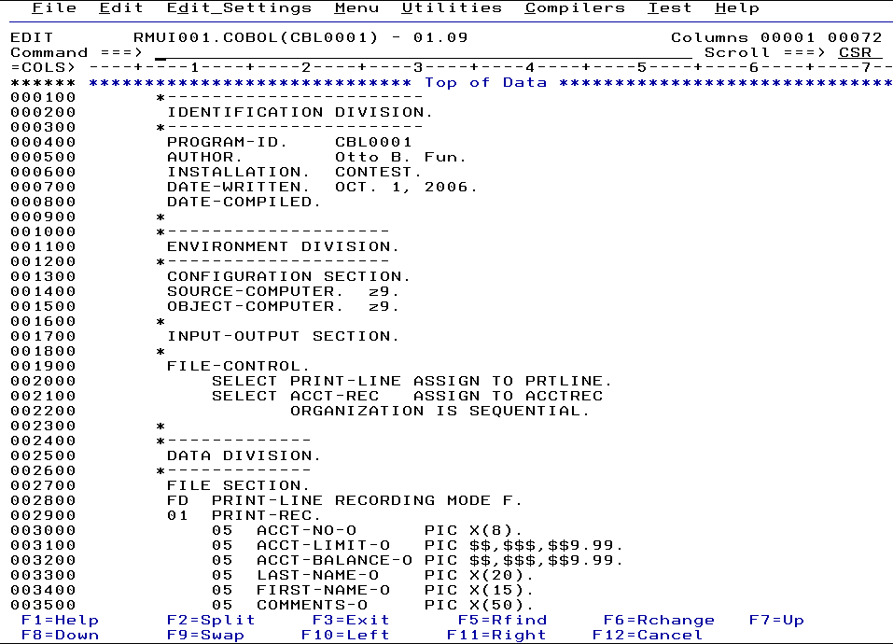 | Step 1. Using an editor (write) the source program code using the rules (syntax) of the program language. An editor is similar to a word processor, except it is design to make writing a program easier and does not use special characters that the compiler does not understand.  In COBOL, one may use the ISPF or RDz editors. Visual Studio is a .NET program language editor. Eclipse and Net Beans are popular for Java, and Microsoft Notepad may be used as a universal program editor.
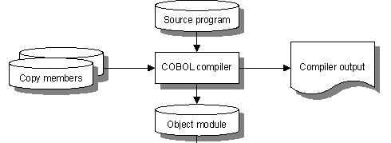 | Step 2. Once the Source Program has been edited, it must be compiled or translated. COBOL program source code is very English-like. The trouble is that no computer understands English.  Computer source programs must be translated in binary (electronic on and off pulses) in a format that may be eventually executed by a computer. The source program is translated and the results are stored in an object module (data set member) or file.  Object modules cannot be executed and must be combined with other object modules. In COBOL the object modules must be compatible with the host operating system. When a Java Class (program) is compiled the results are stored in byte-code file that is in a format that may be executed on different host operating systems.  During compilation is very common that COBOL program may have compile-time, or syntax, errors. These errors must be executed before the process may continue to Step 3.
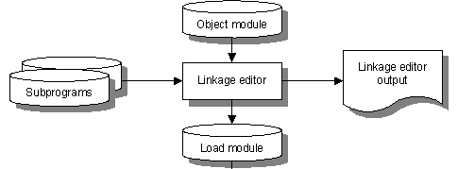 | Step 3. The COBOL object module is next processed (inputted) by the linkage editor program. The linkage editor will create a store a Load Module (data set member) or file.  The role of the linkage editor is to combine subprograms or other object modules that are needed to execute the program. For example, it is very common to code an application is sections that may be reused by other programs, e.g., calculation of a shipping rate. COBOL knows nothing about databases. When COBOL accesses a DB2 or Oracle database, additional programs need to combine with your object modules.  Java does this linkage or combination process on the fly when the byte-code is executed by the Java Virtual Machine. Using this method, Java can customize the process for the host operating, databases, and other hardware resources to be used.
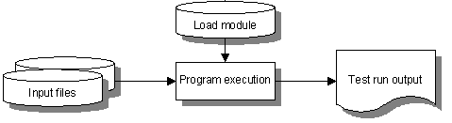 | Step 4. The last step of the COBOL application development process is program execution. In Windows you would click on an icon or menu item to execute an executable file, e.g., EXE file. z/OS call the executable file a load module.  In simple batch processing there is no user interaction. Many batch programs simply inputs a data set, e.g., customer data, to produce a report, e.g., a customer status report. The report or output may contain logic errors, i.e., the incorrect results, or run-time errors, i.e., the data sets were no available.

COBOL Copy Books and Subprograms

The previous diagrams introduced to the concepts of copy books and subprograms. A computer program may be coded in one single, extremely large block of code. In the real-world, many parts of a computer program rely on code that is re-used hundreds, thousands or millions of times. For example, assume a COBOL program requirement would mean that it would need 1,000 lines of source code. But, 900 of those lines were already written by someone else and may be copied, or re-used, it the new application. So does the program write a 1,000 line COBOL program or do they code a 100 line COBOL program and copy the 900 previous lines?

During the COBOL application process there are three points at which the programmer can copy or reuse application code: 1) during compilation, 2) during linkage, or 3) during execution (not illustrated yet). COBOL copy books contain sections of source code that are designed to be reused. The combine a copy book the COBOL statement COPY is used. The program language C uses the #include or #import directives. Java does not an exact statement like this, though the Java import statement is closet concept.

Why do we use copy books? Assume that you require a detailed description of a customer file or database table to be used by 500 different programs. Do you copy-and-paste this description 500 times, or would inserting a COBOL statement, i.e., "COPY CUST.CPY, be easier and more reliable? Every time one recompiles the program one would get the most up-to-date description instead or copying and pasting any changes 500 times.

A COBOL subprogram is merged during Step 3 - Linkage. A Subprogram must be a complete program, a copy book does not. Hence, copy books are very popular for re-using COBOL Data Division code. A Subprogram must be successfully compiled before being merged, a copy book does not. Hence, Subprograms are more popular for re-using COBOL Procedure Division code.

Static versus Dynamic Linkage

The previous graphics illustrated application development using Static Linkage. It is possible to create a load module to be loaded into memory as needed. This is called Dynamic Linkage. Windows and. NET names a collection of load modules that may be dynamically linked a Dynamically Linked Library (DLL). Dynamically loading executable modules into memory as needed conserves memory, but will also increase the performance overhead to find and load later.

The compatibility of using dynamically linked modules is tested during execution-time. Did you ever see a "Send Report to Microsoft, or Firefox, or whatever … message?" This means that an incompatibility may have been discovered, which may have been caused by your failure to keep your computer properly updated.

z/OS cannot accept this performance penalty or unexpected incompatibility error. Rarely does z/OS use dynamic linkage with applications. Static linkage checks for this incompatibility issues during the application development process. If the load module executed 40 years ago, it will execute now with no expected problems.

3.0 C Application Development Process

The C Application Development is similar to

Step 1. Write or edit the C Source code using some type of editor.
Step 2. Translate the C Source Code
Step 3. Link the Object Code.
Step 4. Execute and Debug the C executable file

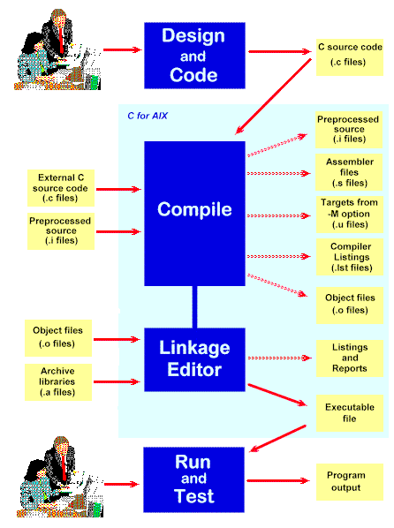
The solid lines show inputs into each step of the development cycle. Compiler and linkage editor operations are performed by the C for AIX product, which also lets you specify what optional outputs are produced. Optional outputs are shown in the diagram by the broken lines. Descriptions of the steps follow below:
Design and Code | Involves designing a program to meet a specified requirement, and creating the programming language text files that will comprise the program source.
Compile | After checking for syntactical correctness, converts the programming language source files into machine readable instructions, where C variables are associated with memory addresses, and C statements are turned into a series of machine language instructions. The compiler can produces various forms of output, depending on the compiler options selected.
Linkage Editor | Links compiler output with external modules requested by the compiled program. C programs can use routines from C libraries or any object or archive file from the IBM XL family of languages. C programs can also use modules produced by the current or previous compilations. As well as linking the external modules, the linkage editor resolves addresses within the object module.
Run and Test | This stage can be both the final step in program development, or it can be an intermediate point in the program design and implementation process. A program's design commonly is further refined as a result of information gathered during testing.

The following 4.0 section is designed Application Security Classes and will not be required for Operating Systems Courses.

4.0 C/C++ Vulnerabilities - Stacks, Heaps, and Pointers

In procedural programming languages one would declare variables once and they would be statically compiled and allocated memory space only once. But, if a program required a large memory space to store variables and their content then this may cause a memory utilization problem. Assume that a COBOL or C program would need 100K of variable storage. When the program starts executing a 100K is reserved (the maximum required), even though the memory area may not be needed except under are conditions or much later during the processing of the program.

This inefficient memory utilization problem is similar to the scenario of your instructor visiting Sam's Club to purchase a large gallon container of Heinz Ketchup. (My kids love Heinz Ketchup.) My wife would complain that a gallon of Heinz Ketchup would last for over a year. Of course being a charge, I responded "Sooooo". The response was "Soooo - we are wasting storage space for all of these large containers and the Ketchup will go bad." Given that in the Year 2000 a gigabyte of RAM was much more expensive than a gallon of Heinz Ketchup. Computer scientists consider the gallon size Heinz Ketchup problem long before I was put in my place.

4.1 Stacks

A Storage Stack is special region of memory that stores temporary variables or objects created by each method or function. The stack is first-in last-out data structure that is automatically managed and optimized by the CPU quite closely rather than the programmer. Every time a method or function declares a new variable, it is “pushed” onto the stack. After the method or function has completed execution the method stack space is automatically erased (freed). To continue the analogy this is similar to purchasing Heinz Ketchup for each meal using packets, rather than gallon containers. Therefore, the size of a stack is quite limited and is only applicable to method or loop scope (local variables and objects).

A stack memory area may also be called a buffer. Technically a buffer is a temporary, fixed size storage area that is shared by computer hardware and processes to store or move data during the execution of a program. A buffer is frequently used various input and output operations, e.g., writing file content to auxiliary storage or data to a network interface.

STACKS are a data structure that exhibits LIFO behavior. Elements can be added to the stack (pushed onto the stack). However, only the element that has been added the most recently can removed (pushed) from the stack. Given an array or relative file with 3 locations:

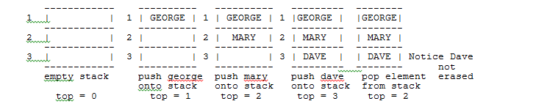

4.1.1 Advantages and Disadvantages of a Stack

Advantages of a Stack | Disadvantages of a Stack
Very efficient in terms of storage space and execution time | A stack is not order by any natural key. There is only an implied arrival order that the element at the top was the one most recently arrived even though we did not store the time of insertion
Data is ordered by a LIFO arrival order | Requires a sequential search to search for a specific record.  Average sequential search = maximum number of records/2 + 1, e.g. if there was 1000 records, it would take on the average 501 sequential accesses to find a given record.

4.1.2 Using Stacks for Memory Management
1. A stack manages memory space allocation for operating systems, variables and programs. For example, every new program loaded into the PCs memory is pushed on the memory stack, Exiting a program does not erase a program, but merely resets the entry point for the current program to a new "top of stack".

What does it mean to "shell to the Windows command line". When one types CMD and he the RUN Prompt the command shell is loaded in separate address space than Windows. It you type CMD again a second command line is loaded on top of the pervious command shell. This similar of putting a hat on top of your head, then putting a second hat on top of the previous hat, etc.,

What does the EXIT at command line accomplish? The EXIT release the address space from command shell and returns to the previous program, e.g., Windows, Word, etc. It is analogous to removing the top hat on your head and return to the previous layer.

4.1.3 Using Stacks for Backtracking

An execution stack manages the backtracking process for GOSUBS, Program and Methods CALLs (invocation) and the COBOL Program. The example uses the old-fashion Basic GOSUBs because it uses program line numbers. When a GOSUB is executed a program pushes the line to return to. When the RETURN statement is executed (or the end of a COBOL paragraph or method, it pops the line to return to and transfer the program flow back to that point. It is kind of similar to Little Red Riding Hood dropping bread crumbs to find her way home.

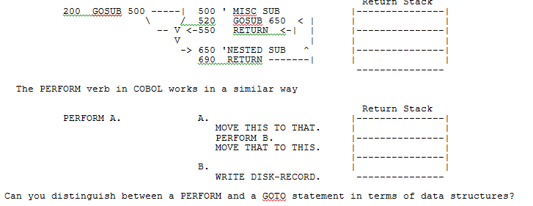

4.1.4 Using Stacks for Mathematic operations

Stacks are also used to for execute math operations. For example 1) push the first operand (number) on the equation stack, push the second operand (number) on the equation stack, when the operator is encountered pop the top two elements, execute the math operation and push the answer on the equation stack .

There are three types of mathematical notations: INFIX, PREFIX, and POSTFIX. While humans are accustomed to understanding INFIX notation, a program language must convert the INFIX notation to POSTFIX notation to execute the mathematical expression.

INFIX 3 + 4 operand, operator, operand
PREFIX + 3 4 operator, operand, operand
POSTFIX 3 4 + operand, operand, operator

Program Concept | Description
Variable or Identifier | A symbolic name of a memory address, which will store programmer data content like the junk mail in your mailbox.
Data Type | The describes the type of data that may be stored at a memory location and the program operations, e.g., math, logical comparisons, etc., that may be performed on the contents of the memory location
Object | A data structure which contains one or more variables used to store data and methods which may process data.
Pointer | A storage structure that store a memory location that may be used to access other variables or storage areas which in turn contains content.
Array | A data structure that stores multiple related values of the same data type.
Buffer | A temporary, fixed size storage area that is shared by computer hardware and processes to store or move data during the execution of a program

4.1.5 Memory Leaks
Automatic garbage collection is memory management strategy that application to release m
Memory occupied by objects that are no longer in use by the program during execution.

4.1.6 Dangling pointer vulnerabilities
Dangling pointer vulnerabilities may occur when a piece of memory is freed while there are still pointers to it, but when the memory has been reassigned to another use, the results will be unpredictable.

4.1.7 Double free vulnerabilities
Double free vulnerabilities may occur when a program tries to free a region of memory that has already been freed, and perhaps had already been reassigned to another use, with unpredictable results.

4.1.8 Stack-based buffer overflow attacks
Stack-based buffer overflow attacks occurs when a program writes to a memory address on the programs call stack outside the intended data structure; usually a fixed length buffer. A typical method for exploiting a stack based overflow is to overwrite the function return address with a pointer to attacker-controlled data. This attack may cause a program to ABEND and leave the program at a command prompt while using the same permissions of the person who originally executed the program. A second scenario will alter the return address to return to a location with a malware program.

4.2 A Heap overflow attack
A Heap overflow attack is similar to a stack overflow, except you overflow a buffer on the heap, which is memory which stores variables that is expected to remain in use while a program continues or is shared with another program with a Linkage data storage. From the heap it is sometimes possible to overwrite procedure linkage information which shared by with another program. If you are able to overwrite the procedure linkage table then you can redirect the control of a program anywhere you want.

4.3 C/C++buffer overflow attack procedures
1. The attacker sends data to a program, which it stores in an undersized stack buffer.
2. The result is that information on the call stack is overwritten, including the function's return pointer.
3. The data sets the value of the return pointer so that when the function returns.
4. Program control it transferred to malicious code contained in the attacker's data.

4.3 Classic C/C++ Format String attack
1. The attacker sends data to a program which includes format string command delimiters. %x, %s, etc.
2. The input string is processed by a program language string function by the application, .e.g., printf, fprintf, snprint, sprint, vprintf, vsprintf, etc.
3. When executed, the attacker could execute code, read the stack, or cause a segmentation fault in the running application.
4. Unexpected behaviors could compromise the security or the stability of the application or system.

4.4 Methods used to prevent Buffer Overflow attacks

4.1 Safe libraries
Safe libraries are well-written and tested abstract data type libraries which centralize and automatically perform buffer management, include bounds checking, can reduce the occurrence and impact of buffer over flows. “Safe” library implementations include “The Better String Library”, Vstr and Erwin.

4.2 Buffer overflow protection
Buffer overflow protection is used to detect the most common buffer overflows by checking that the stack has not been altered when a function returns. If it has been altered, the program exits with a segmentation fault. Three of these buffer overflow protection libraries are Libsafe, and the StackGuard and ProPolice's gcc patches.

4.3 Executable space protection
Executable space protection prevents execution of code on the stack or the heap. An attacker may use buffer overflows to insert arbitrary code into the memory of a program, but with executable space protection, any attempt to execute that code will cause an exception.

4.8 Address space layout randomization (ASLR)
Address space layout randomization (ASLR) is a computer-based security feature which involves arranging the positions of key data areas, usually including the base of the executable and position of libraries, heap and stack, randomly in a process’ address space.

